JAVA AWT BASED -ONLINE STREAMING OF VIDEO DATABASE SYSTEM -SQL CONNECTIVITY USING JDBC

A report submitted in partial fulfillment of the Requirements for the award of the degree of

**BACHELOR OF ENGINEERING**

**IN**

**INFORMATION TECHNOLOGY**

**By- M.Sannihitha (1602-18-737-104)**

**Under the guidance**

**Of**

**B.Leelavathy**

**Department of Information Technology**



**VASAVI COLLEGE OF ENGINEERING**

**AUTONOMOUS (AFFILIATED TO O.U)**

**IBRAHIMBAGH, HYDERABAD-500031**

**2019-20**

**BONAFIDE CERTIFICATE**

This is to certify that this project report titled

**“**ONLINE STREAMING OF VIDEO DATABASE SYSTEM**”** is the

bonafide mini project work of **Ms. Mula Sannihitha**

Bearing hall ticket number **1602-18-737-104** under the

guidance of **B. Leelavathy** during 4th semester B.E for the

academic year **2019-2020.**

**External Examiner Internal Examiner**

B.LEELAVATHY

Assistant professor

Department of Information Technology

**AIM AND PRIORITY OF THE PROJECT:**

To create a GUI based form for the project of ONLINE

STREAMING OF VIDEO DATABASE SYSTEM where in a user

watches a lot of vehicles and the genuineness of the view and keeps

the count of views of all the videos.

The values entered (insertion, updating and deletion) by the user for

Respective table in **GUI** should be updated in the database

using **JDBC.**

**ABSTRACT:**

This project is application software developed for monitoring the online video streaming which mainly focuses on basic operations like uploading a video, updating new information, searching videos and identifying the members who are genuinely watching the video. It is implemented with the help of 5 tables namely USERS, VIEWS, VIDEOS, UPLOADS, ADMIN. The USERS and ADMIN tables consist of information regarding members and the admin respectively. Admin uploads a video which is described in another table namely UPLOADS while the relationship between USERS and VIDEOS tables is established by VIEWS. Uid, Vid, Aid are the primary keys of the tables USERS, VIDEOS, ADMIN respectively and are foreign keys in the tables VIEW and UPLOADS. A one to one mapping for the ADMIN table and a total participation of USERS tables is established.

This article aims to provide a structured approach that admin can use to identify the members who watch the video genuinely and generate reports accordingly.

**A. REQUIREMENTS:**

**Tables Required:** (5) Users, Views, Videos, Uploads, Admin.

|  |  |  |  |
| --- | --- | --- | --- |
| **TABLE** | **DSECRPTION** | **ATTRIBUTE** | **DATATYPE** |
| **USERS** | User ID  User Name  User Password  User Age | usid  name  password  age | NUMBER(20)  VARCHAR2(20)  VARCHAR2(20)  NUMBER(3) |
| **VIDEOS** | Video ID  Video Duration  Video Topic  Number of views of Video | vid  duration  topic  numviews | NUMBER(20)  NUMBER(20)  VARCHAR2(20)  NUMBER(20) |
| **VIEWS** | User ID  Video ID  Genuineness of the View | usid  vid  genuineness | NUMBER(20)  NUMBER(20)  VARCHAR2(20) |
| **ADMIN** | Admin ID  Admin Name  Admin Age | aid  name  age | NUMBER(20)  VARCHAR2(20)  NUMBER(3) |
| **UPLOADS** | Video ID  Admin ID  Time of Upload | vid  aid  since | NUMBER(20)  NUMBER(20)  VARCHAR2(10) |

**C.ARCHITECTURE AND TECHNOLOGY USED:**

Java Eclipse, Oracle 11g Database, java SE version 8, SQL *plus, java AWT

**Eclipse:** It is an integrated development environment (IDE) used in computer programming. It contains a base workspace and an extensible plug in system for customizing the environment. The Eclipse software development kit (SDK), which includes java development tools is meant for java developers.

**SQL *plus:** SQL *plus is a command line tool proprietary to oracle. You can send SQL Queries to the server using the tool. It can also help you format the result of a query. SQL is the query language that is used to communicate with the oracle server to access and modify data.

**JAVA AWT:** Abstract window toolkit is an API to develop GUI or Window based applications in java. Java AWT components are platform dependent i.e., components are displayed according to the view of the operating system. AWT is a heavy weight that is components are using the resources of O.S.

**JDBC:** Java Database Connectivity is an application programming interface (API) for the programming language java**,** which defines how a client may access a database. It is a java based data access technology used for java database connectivity. It is part of the java Standard Edition Platform, from Oracle Corporation.

**D.ER DIAGRAM OF THIS PROJECT:**

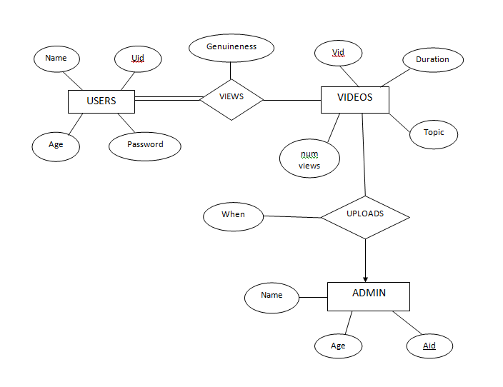

**OUTPUTS**

**DDL COMMANDS**

1. **Users**
2. **Videos**
3. **Views**
4. **Admin**
5. **Uploads**

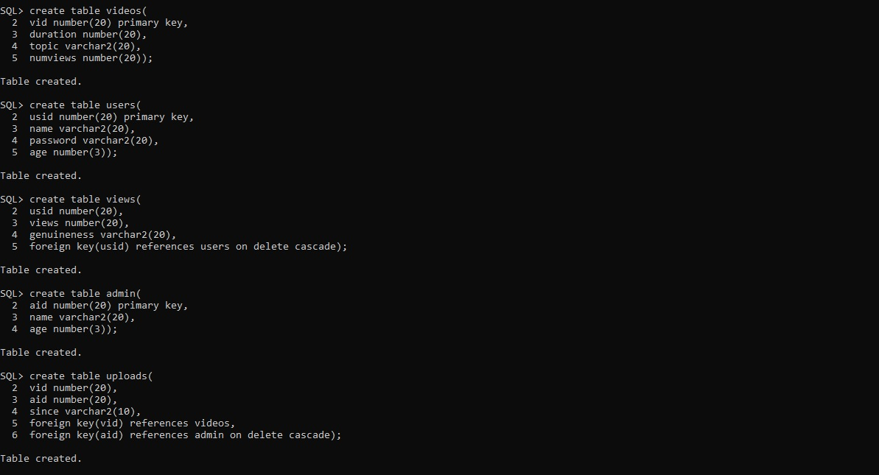

**DESCRIPTION OF TABLES**

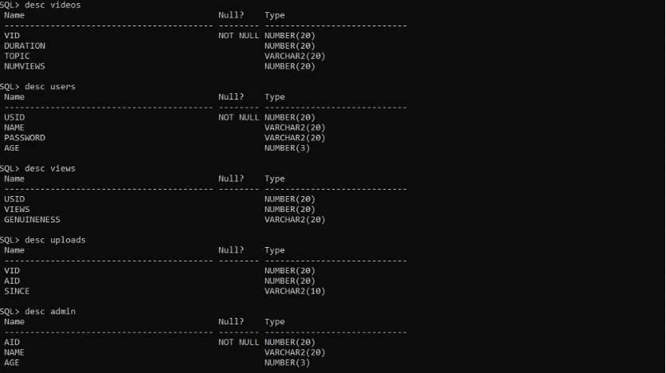

**E. JAVA-SQL CONNECTIVITY USING JDBC:**

**I) FRONT END PROGRAMS AND CONNECTIVITY**

The connection to the database can be performed using java programming **(JDBC API)** as**:**

public void connectToDB() {

try {

connection=DriverManager.getConnection("jdbc:oracle:thin:@localhost:1521:ORCL","**msr","vasavi"**);

statement = connection.createStatement();

}

catch (SQLException connectException) {

System.out.println(connectException.getMessage());

System.out.println(connectException.getSQLState());

System.out.println(connectException.getErrorCode());

System.exit(1);

}

catch(Exception e){

System.out.println("Unable to find and load driver");

System.exit(1);} }

AS THIS PROJECT CONTAINS 5 TABLES

i.**e. USERS,VIDEOS,VIEWS,ADMIN & UPLOADS.**

BELOW IS THE CODE FOR ALL **DML OPERATIONS** ON THE TABLE **USER**

**INSERT USER:**

import java.awt.*;

import java.awt.GridLayout;

import java.awt.event.*;

import java.sql.*;

public class InsertUser extends Frame

{

Button insuserbtn;

TextField usidtxt, nametxt, pwdtxt, agetxt;

TextArea errtxt;

Connection connection;

Statement statement;

public InsertUser()

{

try

{

Class.forName("oracle.jdbc.driver.OracleDriver");

}

catch (Exception e)

{

System.err.println("Unable to find and load driver");

System.exit(1);

}

connectToDB();

}

public void connectToDB()

{

try

{

connection = DriverManager.getConnection("jdbc:oracle:thin:@localhost:1521:xe","msr","vasavi");

statement = connection.createStatement();

}

catch (SQLException connectException)

{

System.out.println(connectException.getMessage());

System.out.println(connectException.getSQLState());

System.out.println(connectException.getErrorCode());

System.exit(1);

}

}

public void buildGUI()

{

insuserbtn = new Button("Enter");

insuserbtn.addActionListener(new ActionListener()

{

public void actionPerformed(ActionEvent e)

{

try

{

String query= "INSERT INTO users VALUES(" + usidtxt.getText() + ", " + "'" + nametxt.getText() + "'"+"," +"'"+ pwdtxt.getText() +"'"+ "," + agetxt.getText() + ")";

int i = statement.executeUpdate(query);

// System.out.print("jgig\nbj");

errtxt.append("\nInserted " + i + " rows successfully");

// System.out.print("jgig\nbj");

}

catch (SQLException insertException)

{

displaySQLErrors(insertException);

}

}

});

usidtxt = new TextField(15);

nametxt = new TextField(15);

pwdtxt = new TextField(15);

agetxt = new TextField(15);

errtxt = new TextArea(10, 40);

errtxt.setEditable(false);

Panel first = new Panel();

first.setLayout(new GridLayout(4, 2));

first.add(new Label("User ID:"));

first.add(usidtxt);

first.add(new Label("Name:"));

first.add(nametxt);

first.add(new Label("Password"));

first.add(pwdtxt);

first.add(new Label("Age:"));

first.add(agetxt);

first.setBounds(125,90,200,100);

Panel second = new Panel(new GridLayout(4, 1));

second.add(insuserbtn);

second.setBounds(125,220,150,100);

Panel third = new Panel();

third.add(errtxt);

third.setBounds(125,320,300,200);

setLayout(null);

add(first);

add(second);

add(third);

setTitle("INSERT USER");

setSize(500, 600);

setVisible(true);

}

private void displaySQLErrors(SQLException e)

{

errtxt.append("\nSQLException: " + e.getMessage() + "\n");

errtxt.append("SQLState: " + e.getSQLState() + "\n");

errtxt.append("VendorError: " + e.getErrorCode() + "\n");

}

public static void main(String[] args)

{

InsertUser user = new InsertUser();

user.addWindowListener(new WindowAdapter(){

public void windowClosing(WindowEvent e)

{

System.exit(0);

}

});

user.buildGUI();

}

**UPDATE USER:**

import java.awt.*;

import java.awt.event.*;

import java.sql.*;

public class UpdateUser extends Frame

{

Button upduserbtn;

List USIDList;

TextField usidtxt, nametxt, pwdtxt, agetxt;

TextArea errtxt;

Connection connection;

Statement statement;

ResultSet rs;

public UpdateUser()

{

try

{

Class.forName("oracle.jdbc.driver.OracleDriver");

}

catch (Exception e)

{

System.err.println("Unable to find and load driver");

System.exit(1);

}

connectToDB();

}

public void connectToDB()

{

try

{

connection = DriverManager.getConnection("jdbc:oracle:thin:@localhost:1521:xe","msr","vasavi");

statement = connection.createStatement();

}

catch (SQLException connectException)

{

System.out.println(connectException.getMessage());

System.out.println(connectException.getSQLState());

System.out.println(connectException.getErrorCode());

System.exit(1);

}

}

private void loadUsers()

{

try

{

rs = statement.executeQuery("SELECT USID FROM users");

while (rs.next())

{

USIDList.add(rs.getString("USID"));

}

}

catch (SQLException e)

{

displaySQLErrors(e);

}

}

public void buildGUI()

{

USIDList = new List(10);

loadUsers();

add(USIDList);

//When a list item is selected populate the text fields

USIDList.addItemListener(new ItemListener()

{

public void itemStateChanged(ItemEvent e)

{

try

{

rs = statement.executeQuery("SELECT * FROM users where USID ="+USIDList.getSelectedItem());

rs.next();

usidtxt.setText(rs.getString("USID"));

nametxt.setText(rs.getString("NAME"));

pwdtxt.setText(rs.getString("PASSWORD"));

agetxt.setText(rs.getString("AGE"));

}

catch (SQLException selectException)

{

displaySQLErrors(selectException);

}

}

});

//Handle Update User Button

upduserbtn = new Button("Update");

upduserbtn.addActionListener(new ActionListener()

{

public void actionPerformed(ActionEvent e)

{

try

{

Statement statement = connection.createStatement();

int i = statement.executeUpdate("UPDATE users "

+ "SET name='" + nametxt.getText() + "', "

+ "password='" + pwdtxt.getText() + "' , "

+ "age ="+ agetxt.getText() + " WHERE usid = "

+ USIDList.getSelectedItem());

errtxt.append("\nUpdated " + i + " rows successfully");

USIDList.removeAll();

loadUsers();

}

catch (SQLException insertException)

{

displaySQLErrors(insertException);

}

}

});

usidtxt = new TextField(15);

usidtxt.setEditable(false);

nametxt = new TextField(15);

pwdtxt = new TextField(15);

agetxt = new TextField(15);

errtxt = new TextArea(10, 40);

errtxt.setEditable(false);

Panel first = new Panel();

first.setLayout(new GridLayout(4, 2));

first.add(new Label("Sailor ID:"));

first.add(usidtxt);

first.add(new Label("Name:"));

first.add(nametxt);

first.add(new Label("Password"));

first.add(pwdtxt);

first.add(new Label("Age:"));

first.add(agetxt);

Panel second = new Panel(new GridLayout(4, 1));

second.add(upduserbtn);

Panel third = new Panel();

third.add(errtxt);

add(first);

add(second);

add(third);

setTitle(“UPDATE USER”);

setSize(500, 600);

setLayout(new FlowLayout());

setVisible(true);

}

private void displaySQLErrors(SQLException e)

{

errtxt.append("\nSQLException: " + e.getMessage() + "\n");

errtxt.append("SQLState: " + e.getSQLState() + "\n");

errtxt.append("VendorError: " + e.getErrorCode() + "\n");

}

public static void main(String[] args)

{

UpdateUser upu = new UpdateUser();

upu.addWindowListener(new WindowAdapter(){

public void windowClosing(WindowEvent e)

{

System.exit(0);

}

});

upu.buildGUI();

}

}

**DELETE USER:**

import java.awt.*;

import java.awt.event.*;

import java.sql.*;

public class DeleteUser extends Frame

{

Button dltuserbtn;

List USIDList;

TextField usidtxt, nametxt, pwdtxt, agetxt;

TextArea errtxt;

Connection connection;

Statement statement;

ResultSet rs;

public DeleteUser()

{

try

{

Class.forName("oracle.jdbc.driver.OracleDriver");

}

catch (Exception e)

{

System.err.println("Unable to find and load driver");

System.exit(1);

}

connectToDB();

}

public void connectToDB()

{

try

{

connection = DriverManager.getConnection("jdbc:oracle:thin:@localhost:1521:xe","msr","vasavi");

statement = connection.createStatement();

}

catch (SQLException connectException)

{

System.out.println(connectException.getMessage());

System.out.println(connectException.getSQLState());

System.out.println(connectException.getErrorCode());

System.exit(1);

}

}

private void loadUsers()

{

try

{

rs = statement.executeQuery("SELECT * FROM users");

while (rs.next())

{

USIDList.add(rs.getString("USID"));

}

}

catch (SQLException e)

{

displaySQLErrors(e);

}

}

public void buildGUI()

{

USIDList = new List(10);

loadUsers();

add(USIDList);

//When a list item is selected populate the text fields

USIDList.addItemListener(new ItemListener()

{

public void itemStateChanged(ItemEvent e)

{

try

{

rs = statement.executeQuery("SELECT * FROM users");

while (rs.next())

{

if (rs.getString("USID").equals(USIDList.getSelectedItem()))

break;

}

if (!rs.isAfterLast())

{

usidtxt.setText(rs.getString("USID"));

nametxt.setText(rs.getString("NAME"));

pwdtxt.setText(rs.getString("PASSWORD"));

agetxt.setText(rs.getString("AGE"));

}

}

catch (SQLException selectException)

{

displaySQLErrors(selectException);

}

}

});

//Handle Delete User Button

dltuserbtn = new Button("Delete");

dltuserbtn.addActionListener(new ActionListener()

{

public void actionPerformed(ActionEvent e)

{

try

{

Statement statement = connection.createStatement();

int i = statement.executeUpdate("DELETE FROM users WHERE USID = "

+ USIDList.getSelectedItem());

errtxt.append("\nDeleted " + i + " rows successfully");

usidtxt.setText(null);

nametxt.setText(null);

pwdtxt.setText(null);

agetxt.setText(null);

USIDList.removeAll();

loadUsers();

}

catch (SQLException insertException)

{

displaySQLErrors(insertException);

}

}

});

usidtxt = new TextField(15);

nametxt = new TextField(15);

pwdtxt = new TextField(15);

agetxt = new TextField(15);

errtxt = new TextArea(10, 40);

errtxt.setEditable(false);

Panel first = new Panel();

first.setLayout(new GridLayout(4, 2));

first.add(new Label("User ID:"));

first.add(usidtxt);

first.add(new Label("Name:"));

first.add(nametxt);

first.add(new Label("Password:"));

first.add(pwdtxt);

first.add(new Label("Age:"));

first.add(agetxt);

Panel second = new Panel(new GridLayout(4, 1));

second.add(dltuserbtn);

Panel third = new Panel();

third.add(errtxt);

add(first);

add(second);

add(third);

setTitle("DELETE USER");

setSize(450, 600);

setLayout(new FlowLayout());

setVisible(true);

}

private void displaySQLErrors(SQLException e)

{

errtxt.append("\nSQLException: " + e.getMessage() + "\n");

errtxt.append("SQLState: " + e.getSQLState() + "\n");

errtxt.append("VendorError: " + e.getErrorCode() + "\n");

}

public static void main(String[] args)

{

DeleteUser delu = new DeleteUser();

delu.addWindowListener(new WindowAdapter(){

public void windowClosing(WindowEvent e)

{

System.exit(0);

}

});

delu.buildGUI();

}

}

**GITHUB LINK AND FOLDER STRUCTURE:**

<https://github.com/SannihithaReddy/DBMS-Assignment>

The zip folder contains all the source codes that are part of this mini project such as other Insert, Update and Delete files of remaining tables.

**OUTPUTS**

**THE FIRST FRAME THAT WILL BE VISIBLE WHEN WE EXECUTE THE PROGRAM WILL BE**

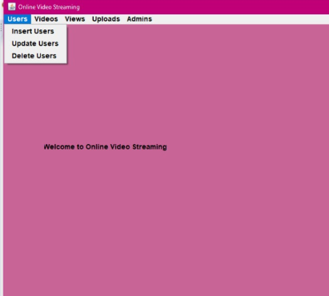

**OUTPUT OF INSERT USER:**

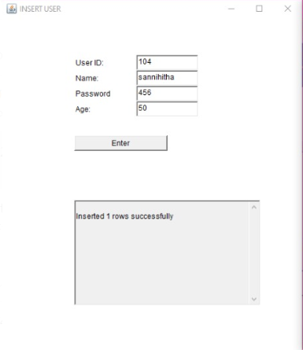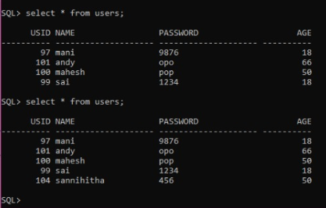

**OUTPUT OF UPDATE USER:**

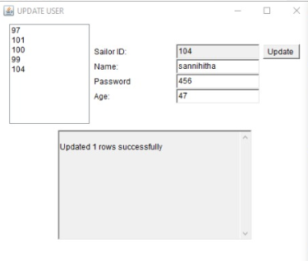 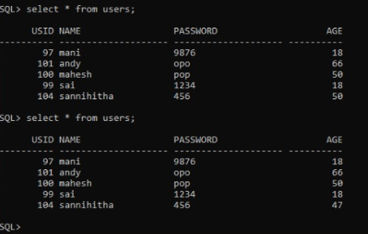

**OUTPUT OF DELETE USER:**

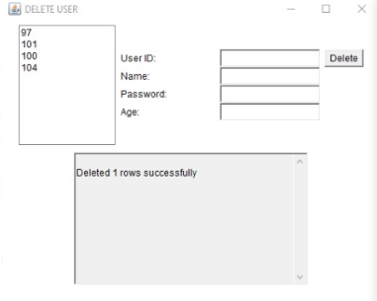 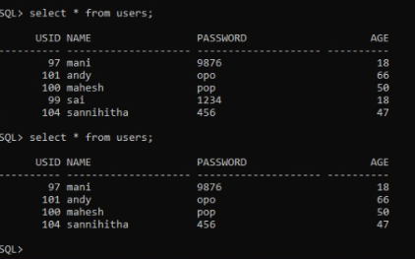

**OUTPUT OF INSERT VIDEO:**

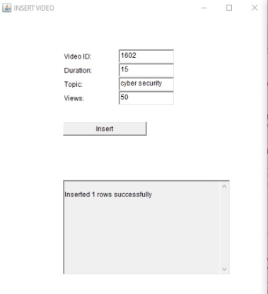 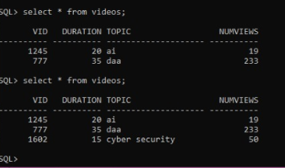

**OUTPUT OF UPDATE VIDEO:**

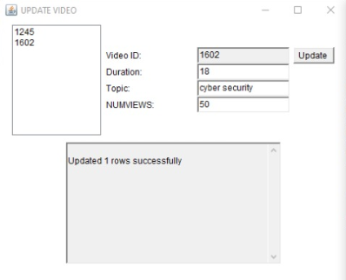 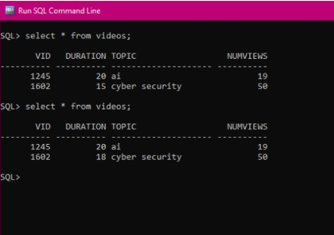

**OUTPUT OF DELETE VIDEO:**

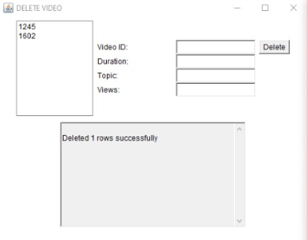 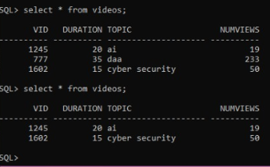

**TESTING:**

If a user enters an invalid value then an error message is displayed and exception is raised.

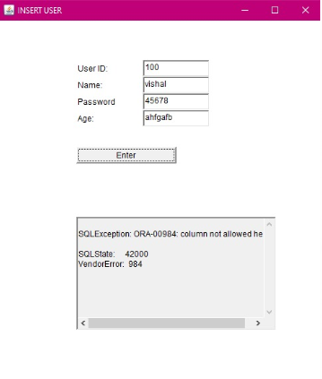

**RESULT:**

The process of entering information into the frame created by java code so that the data is reflected in the database using **JDBC connectivity** is done successfully.

**DISCUSSION AND FUTURE WORK!**

The application till now done is a basic interface in which a user

Can enter the details and watch videos. So **in future the project**

**will be edited in such a manner that will be able to identify the genuine viewers.**

**REFERENCES:**

<https://docs.oracle.com/javase/8/docs/api/>

<https://www.geeksforgeeks.org/establishing-jdbc-connection-in-java/>

<https://www.javatpoint.com/java-awt>